Sitecore Installation Guide (Sitecore 10.4 XM)

**Step 1**: Download Sitecore installation package from [here](https://scdp.blob.core.windows.net/downloads/Sitecore%20Experience%20Platform/104/Sitecore%20Experience%20Platform%20104/Sitecore%2010.4.0%20rev.%20010422%20(Setup%20XM1%20Developer%20Workstation%20rev.%201.6.0-r4).zip).



**Step 2**: Extract the zip file to your preferred folder for e.g. Sitecore 10.4 XM in my case

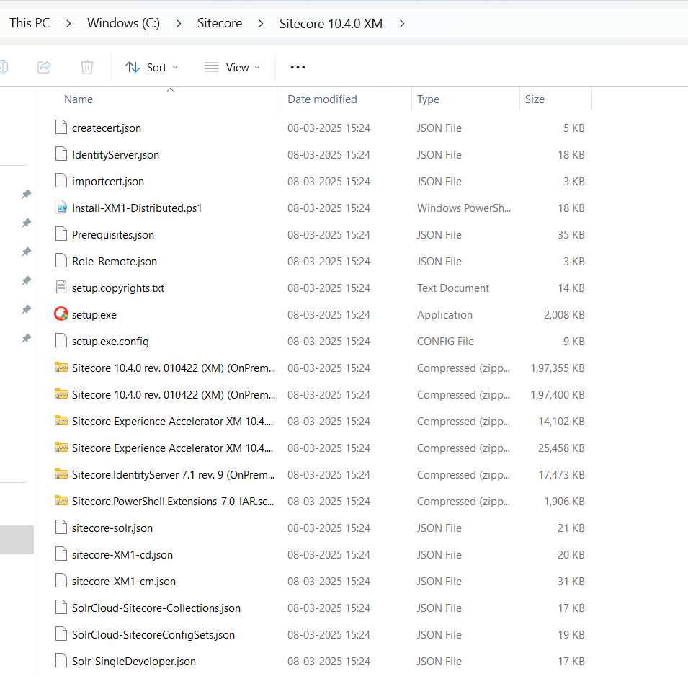

**Step 3**: Run setup.exe file by double clicking it.

**Step 4**: Click on start button.

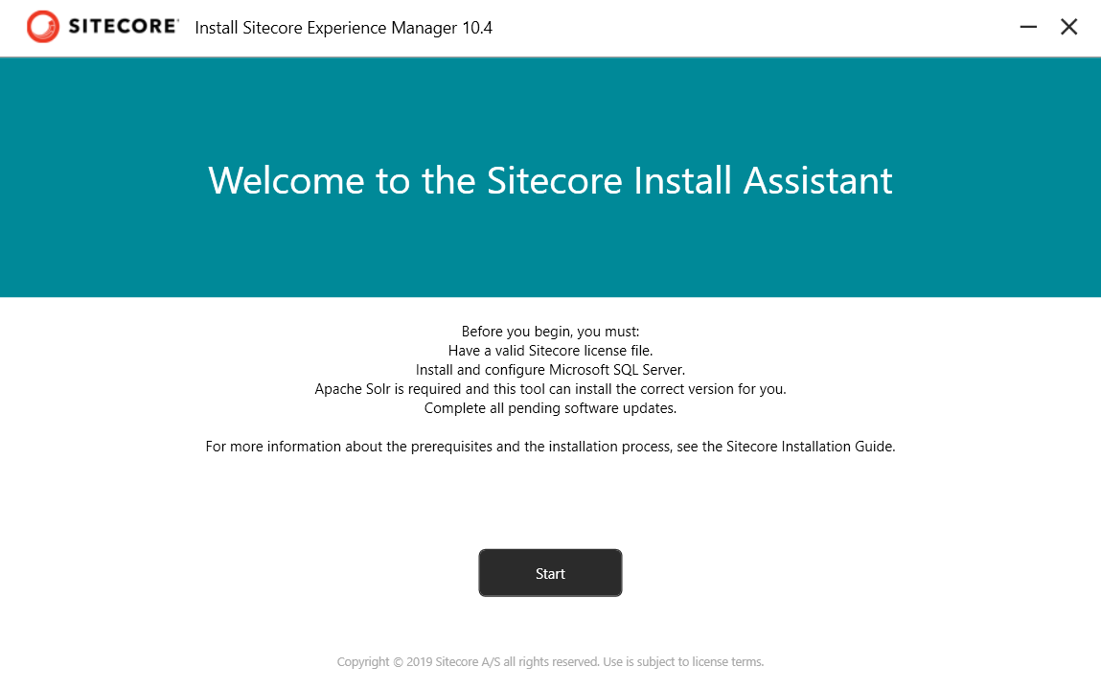

**Step 5**: Click on install-to-install prerequisites. Once installed click on Next button on the right bottom of the screen.

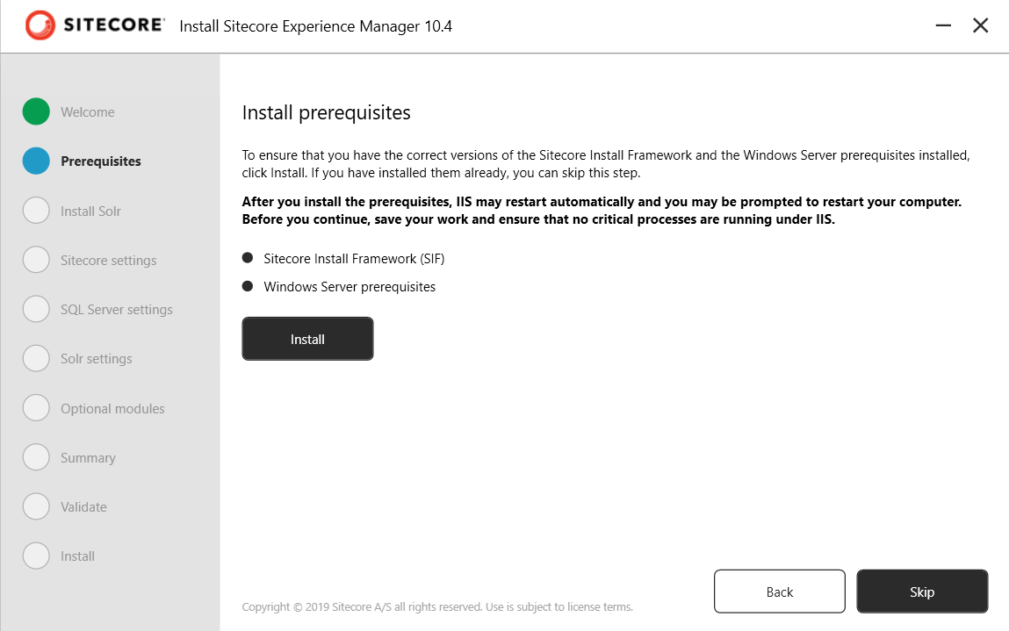

**Step 6**: Install Solr. Fill the Solr port, windows service and path prefix and Solr install path as shown below. Once installed click on next.

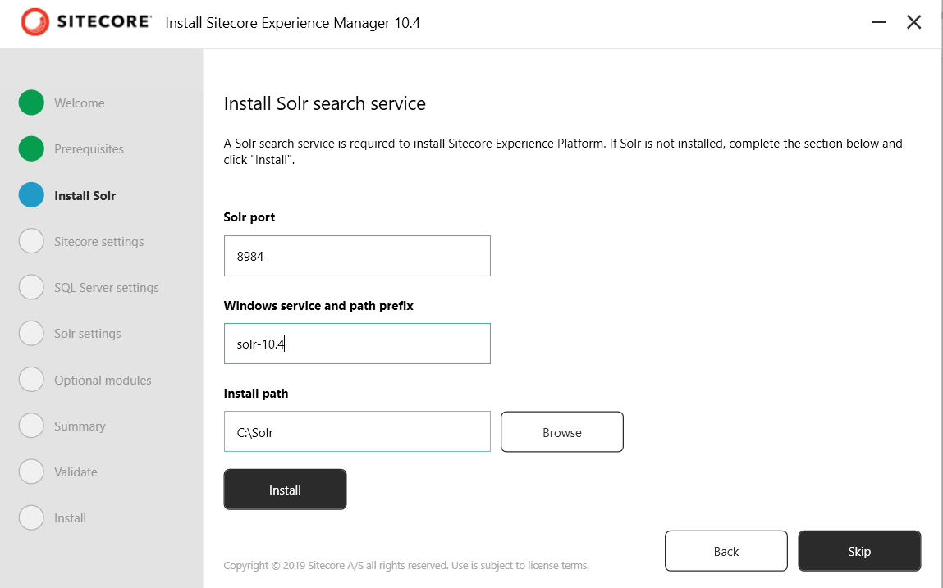

**Step 7**: Fill Sitecore settings as described below and click next:

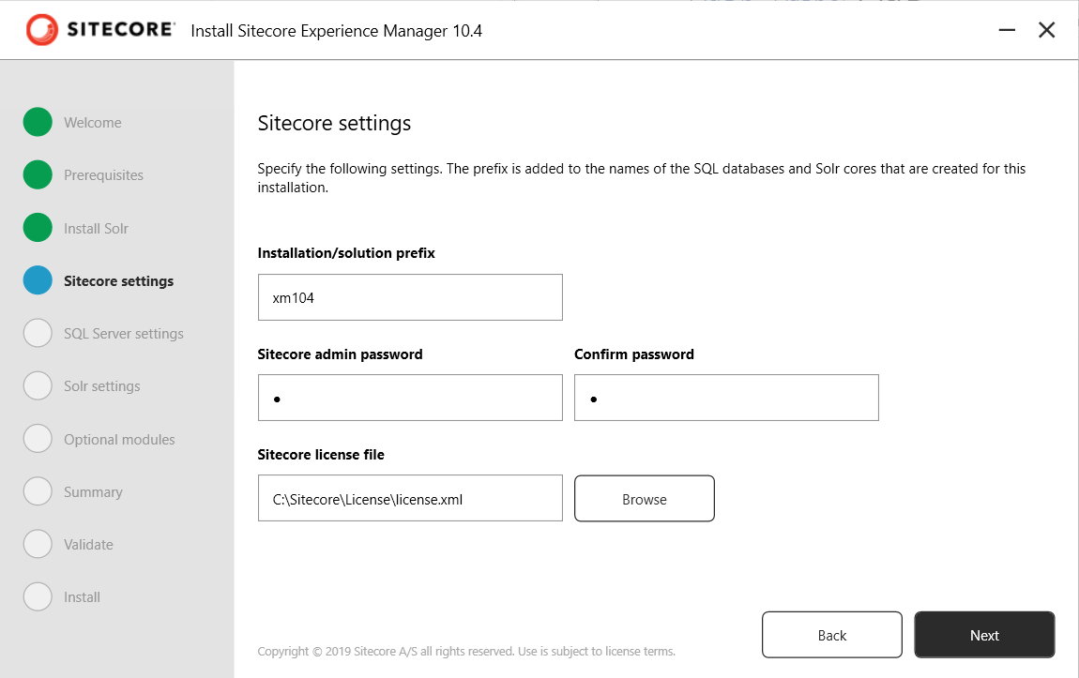

**Step 8**: Fill the SQL server details like Server name, username and password and click next:

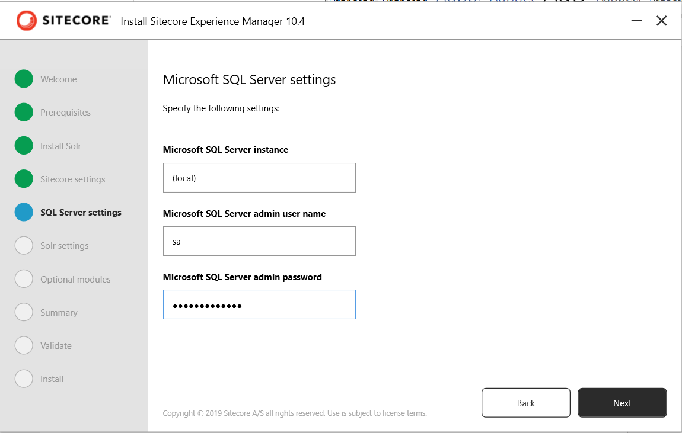

**Step 9**: Check Solr settings (it will populate automatically if you install solr from step 6 else you need to manually fill the same.):

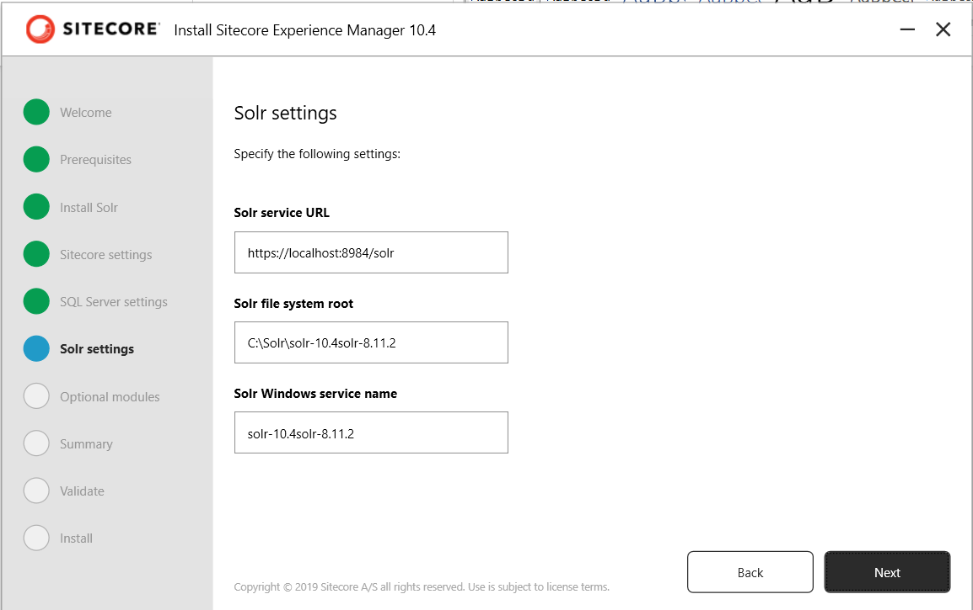

**Step 10**: Install optional module (check the check box if you want to install SXA) and click Next:

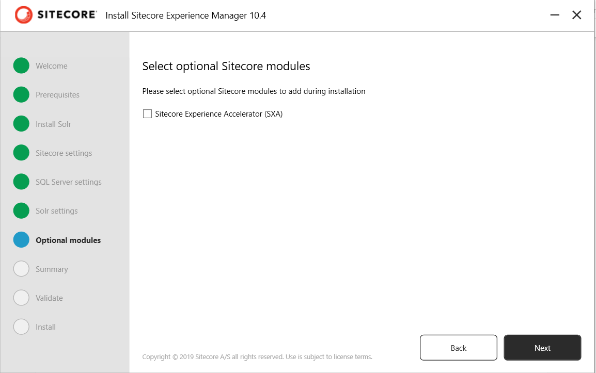

**Step 11**: Cross verify all the details and click Next:

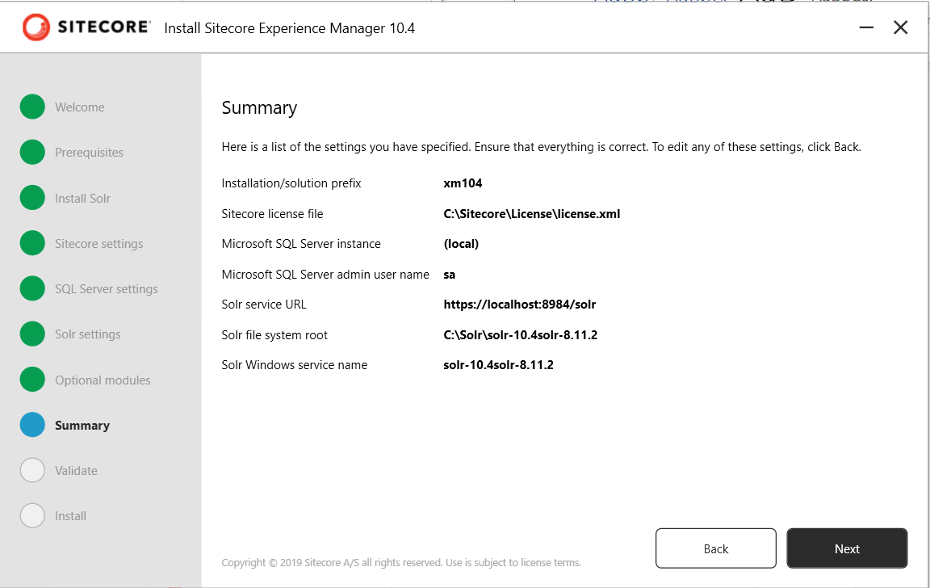

**Step 12**: On clicking Next, the exe will validate all the things such as license file, Solr connection and SQL connection, once all things look good it will show tick marks against all the pointers as shown below. Click on Install button to install Sitecore 10.4 locally.

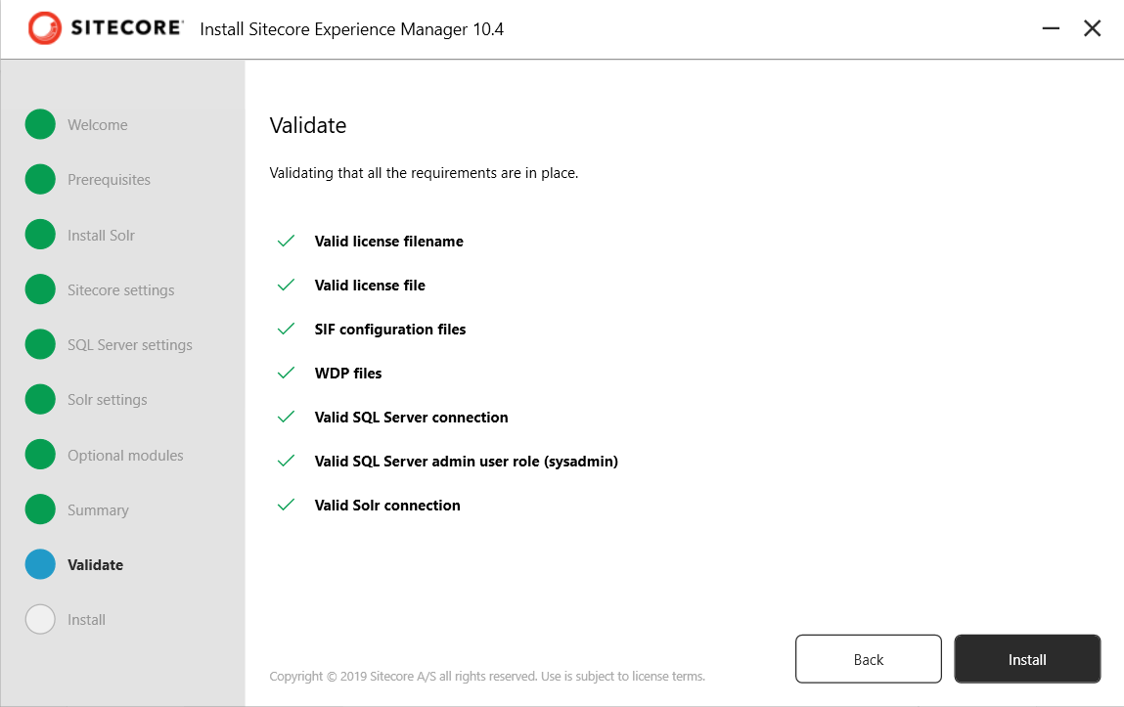

**Step 13**: Once everything goes well you will see the Launch button to launch the Sitecore click on it and it will open the Sitecore login screen in your browser. Login with the credentials which you provided in step 7. Username will be admin.

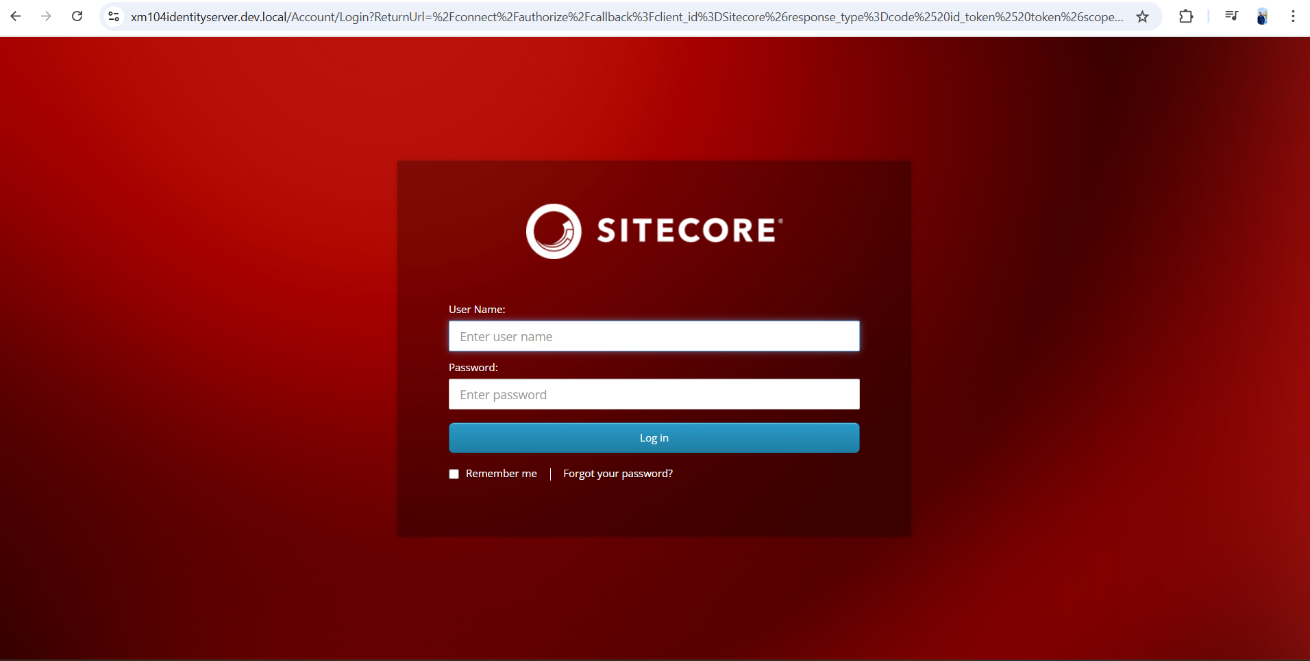

**Step 14**: Sitecore installed successfully.

Errors which might occur while installing Sitecore 10.4

**Error 1**:

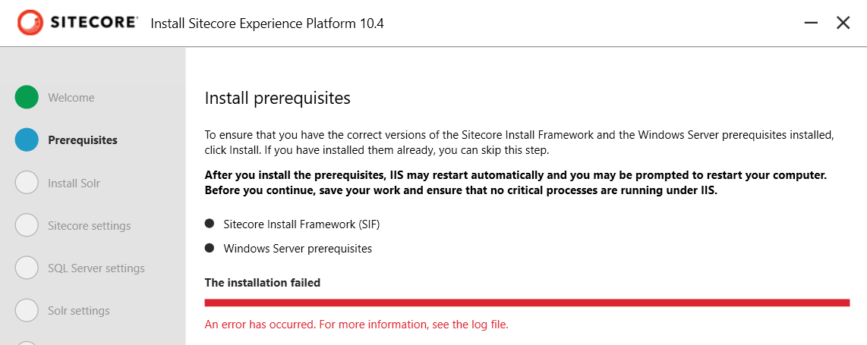

Authenticode issuer 'CN="Sitecore USA, Inc.", OU=IT, O="Sitecore USA, Inc.", L=San Francisco, S=California, C=US' of the new module 'SitecoreInstallFramework' with version '2.4.0' from root certificate authority 'CN=DigiCert Trusted Root G4, OU=www.digicert.com, O=DigiCert Inc, C=US' is not matching with the authenticode issuer 'CN="Sitecore USA, Inc.", O="Sitecore USA, Inc.", L=Sausalito, S=ca, C=US' of the previously-installed module 'SitecoreInstallFramework' with version '2.2.0' from root certificate authority 'CN=DigiCert Assured ID Root CA, OU=www.digicert.com, O=DigiCert Inc, C=US'. If you still want to install or update, use -SkipPublisherCheck parameter.

**Cause**: If you have previously installed any other version of sitecore locally than this error might occur as another exe is unable to install correct version of 'SitecoreInstallFramework' which is needed for Sitecore 10.4 i.e. SIF version 2.4.0

**Solution**:

Run the below command in windows PowerShell (as administrator) to install SIF version 2.4.0.

**Install-Module -Name SitecoreInstallFramework -RequiredVersion 2.4.0 -force -SkipPublisherCheck**

After running this command in PowerShell, install the prerequisites again and follow all the above steps to install Sitecore.